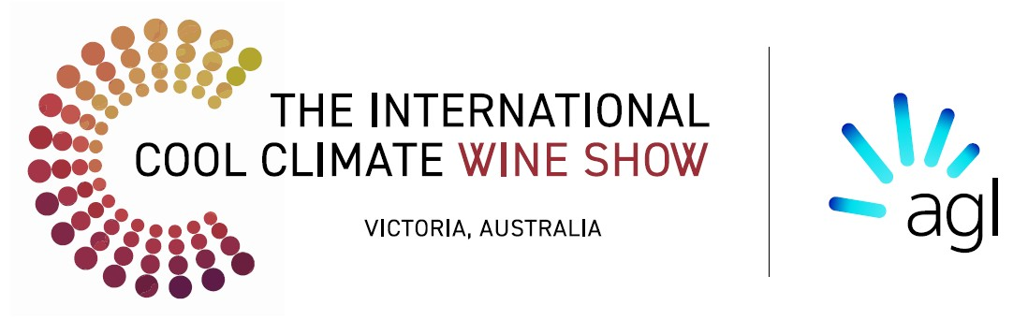

ICCWS “Excellence in Environmental Sustainability” Award

Celebrating Innovation in Sustainable Australian Winemaking Sponsored by AGL

Applications Close at 5pm Monday 6th June 2025

Winery Information

Winery Name:

Address:

Contact Person:

Name:

Position Title:

Email:

Phone Number:

Location (if different to address):

Website (if applicable):

Winery Size
Annual Wine Production:
☐ Under 10,000 cases (12 x 750ml bottles)
☐ 10,000 – 100,000 cases (12 x 750ml bottles)
☐ Over 100,000 cases (12 x 750ml bottles)

Eligibility Check
☐ Australian Cool Climate Wine Producer
☐ Must have entered wine in the ICCWS 2025 Awards Show
☐ Initiatives have recent significance with results achieved within the last 2 financial years

Completing the application
To ensure that your entry is given the best chance of success please describe the initiative/project for one or more of the following categories:

- Sustainability Practices: Describe the sustainable farming practices your winery implemented e.g., renewable energy use, water conservation, etc. (500 words max)

- Waste Reduction and Recycling Initiatives: Outline any waste reduction measures, recycling programs, or packaging solutions you’ve adopted: (300 words max)

- Carbon Footprint Reduction: Detail how you have reduced carbon emissions (300 words max)

- Sustainability Innovation: Describe any innovations that enhance the sustainability of your operations. (300 words max)

Supporting Documentation
Attach up to 5 supporting documents to your application(e.g., certifications, photos, reports) that demonstrate your winery’s commitment to sustainability.

Why Should Your Winery Win the Award?
In your own words, explain why your winery is deserves to win the Award. (300 words max)

Please attach the following required information:
Please attach your Business logo and High-resolution images relating to the initiatives described in your application and email and your completed application to info@internationalcoolclimatewineshow.com

Consent and Declaration:
Multi Choice
☐ I confirm that the information provided in this application is true and accurate to the best of my knowledge.
☐ I agree to allow the judging panel to review and publish my winery’s sustainable practices in connection with this award.
☐ I authorise the use and/or reproduction of any images provided and any other relevant information for promotional purposes
☐ I confirm that I have entered wine in the ICCWS 2025 wine show.
Name: (person completing form)
Signature:
Date:

Important Notes:
- Completed application and supporting documents, logo & images should be submitted to info@internationalcoolclimatewineshow.com.au
- Application deadline 5pm Monday 6 June 2025.
- Shortlisting Announcement June – July 2025
- Winners Announcement Friday 29 August 2025 at the Awards Dinner and featured in industry publications.
- Should you need assistance about the application process contact us by email vp@internationalcoolclimatewineshow.com.au

Disclaimer:
The information provided in the ICCWS “Excellence in Environmental Sustainability Award” application is for the purpose of assessing eligibility and evaluating the sustainability practices of participating wineries. By applying entrants agree to allow the judging panel to review and publish their sustainable practices in connection with this award. All information submitted will be treated with confidentiality and used solely for the purpose of this award. The ICCWS reserves the right to use and/or reproduce any images and information provided for promotional purposes. Personal data will be handled in accordance with our privacy policy and will not be shared with third parties without explicit consent.

